**Two-way Binding**

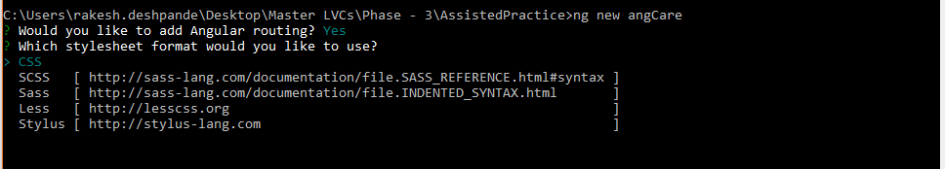

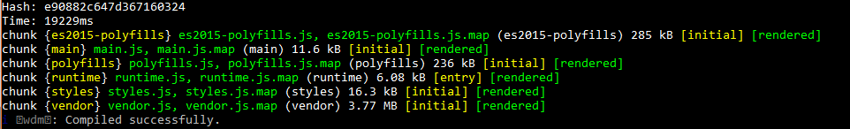

import { BrowserModule } from '@angular/platform-browser';

import { NgModule } from '@angular/core';

import { AppRoutingModule } from './app-routing.module';

import { AppComponent } from './app.component';

import { ChildComponent } from './child/child.component';

@NgModule({

declarations: [

AppComponent,

ChildComponent

],

imports: [

BrowserModule,

AppRoutingModule

],

providers: [],

bootstrap: [AppComponent]

})

export class AppModule { }

Add below code in app.component.ts

import { Component } from '@angular/core';

@Component({

selector: 'app-root',

templateUrl: './app.component.html',

styleUrls: ['./app.component.css']

})

export class AppComponent {

public cdata: string;

}

Add below code in app.component.html

<h2>Parent Component</h2>

This is Parent Component<br>

Enter Text:

<input type="text" #ptext (keyup)="0"/><br>

The value of Child component is: {{cdata}}

<app-child (cevent)="cdata=$event" [pdata]="ptext.value"></app-child>

Add below code in child.component.html

<h2>Child Component</h2>

This is Child Component<br>

Enter Text:

<input type="text" #cdata (keyup)="onChange(cdata.value)"/><br>

The value od Parent component is: {{pdata}}

Add below code in child.component.ts

import { Component, OnInit, Input, EventEmitter } from '@angular/core';

@Component({

selector: 'app-child',

templateUrl: './child.component.html',

styleUrls: ['./child.component.css'],

inputs: [`pdata`],

outputs: [`cevent`]

})

export class ChildComponent implements OnInit {

constructor() { }

ngOnInit() {

}

public pdata: string;

cevent= new EventEmitter<string>();

onChange(value:string){

this.cevent.emit(value);

}

}